Davian Peterson

HWRS 482

1/26/21

Challenge 2

Question 1

As head drops directly from 15 to 10 meters, flux remains constant throughout the medium and holds a steady state condition. This is because both K and change in head are constant along the x axis.

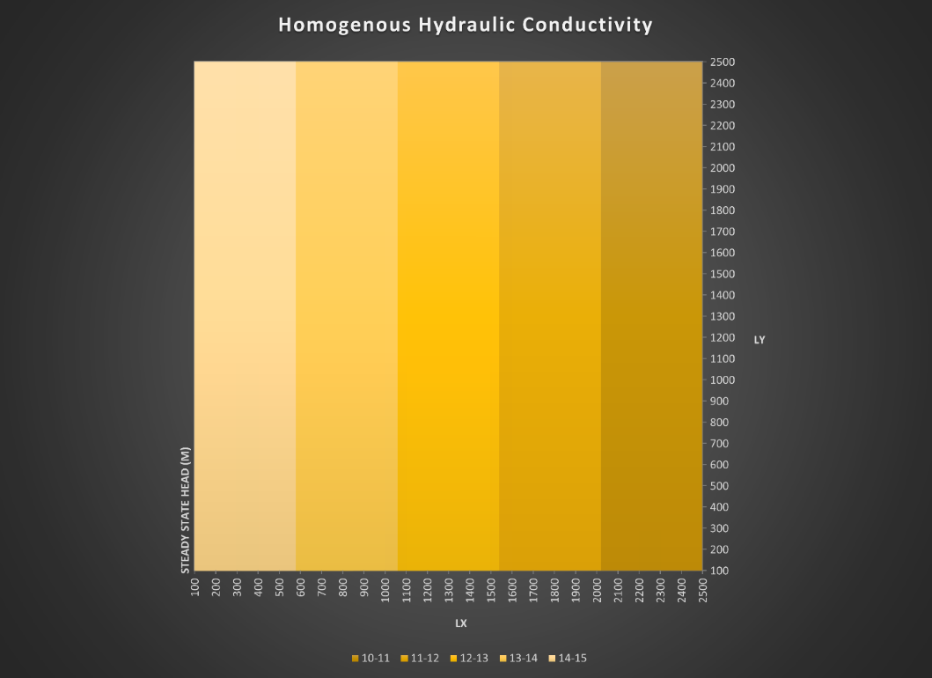

Figure 1: characterization of head through a medium of homogenous hydraulic conductivity

Figure 2: characterization of flux through a medium of homogenous hydraulic conductivity

Question 2

While head changes at different rates horizontally, deltaH is equal between high and low Y. Keq can be modeled using a harmonic mean which produces an output that favors lower inputs. You can also think about it like the low K is restricting the rest of the flow like if you stuck a sponge in a hose. In terms of energy, most of the water’s is spent in conditions of low hydraulic conductivity. I’m still unsure how these two ways of thinking about it are related and how a harmonic mean is able to represent it.

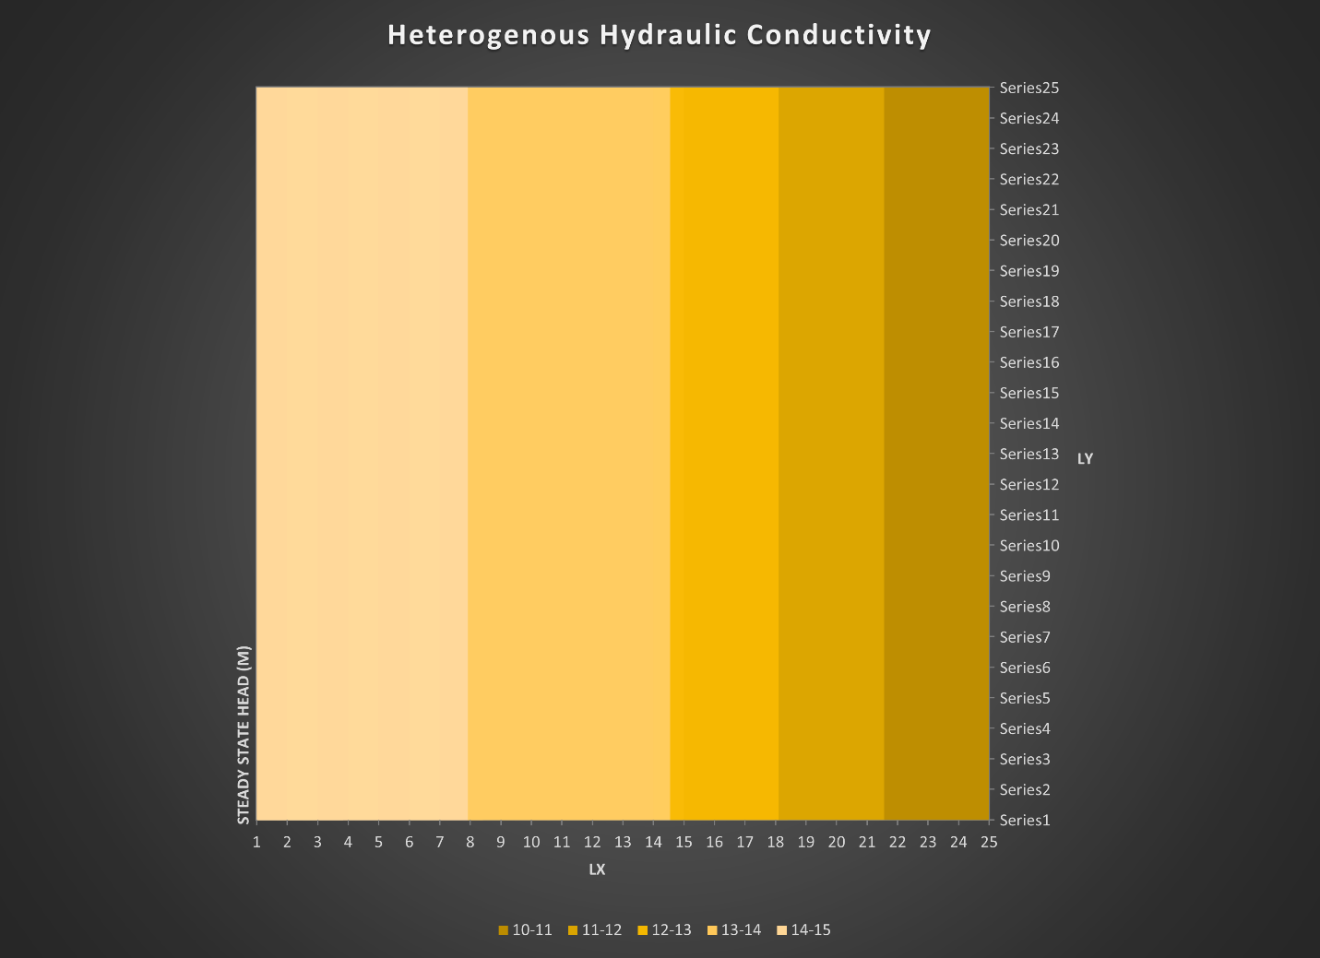

Figure 2: characterization of head through a medium of heterogenous hydraulic conductivity

Question 3

It appears that areas of lower hydraulic conductivity draw the contours in. Despite the greater K occupying a greater area, Keq is likely restricted by the lower K. In this model, you have distinctions between Ks that exist parallel and perpendicular to flow and not a very intuitive way to balance the two methods for deciding how Keq is impacted. It sounds like finding Keq for this kind of situation would require a lot of time if it were done 1 by 1 given that you’d have to find K in two dimensions (K_xx, K_xy, etc). We also discussed how while the contours move into the low K, the perpendicular flow lines are directed away, taking the path of least resistance and using its energy at a slower rate.

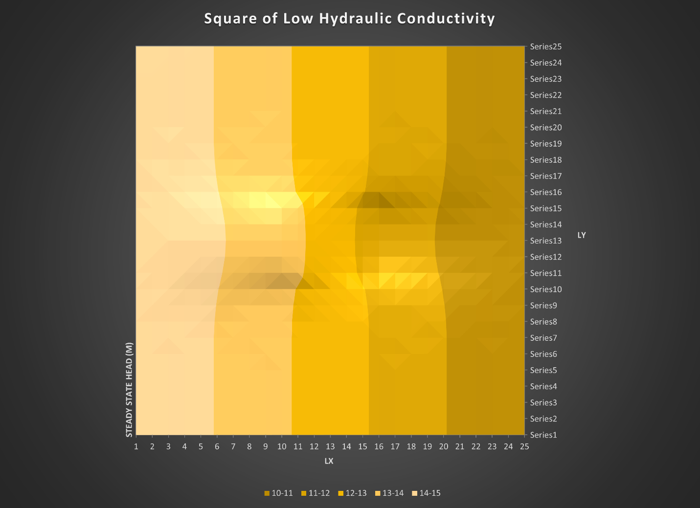

Figure 3: characterization of head through a medium where the center is less conductive